**SQL Queries**

1. **Total Number of Accidents**

select COUNT(Distinct Accident_index) as Total_No_Accidents from [Road Accident Data];

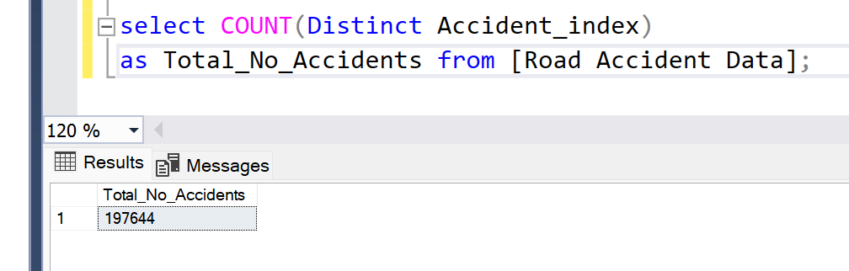

1. **Total Number of Casualties**

select SUM(Number_of_Casualties) as Total_Casualties from [Road Accident Data];

